

VILNIUS UNIVERSITY
SIAULIAI ACADEMY
BACHELOR PROGRAMME SOFTWARE ENGINEERING

SYSTEM APPLICATIONS AND PRODUCTS IN DATA PROCESSING (SAP)

E-service Design Principles and Infrastructure Solutions. Practical Work № 9

Student :
Lecturer: Prof. Dr. Dale Dzemydiene

Siauliai, 2023

Step 1: Create cost center
Task: Create a cost center for asset procurement in the Fiori Launchpad.
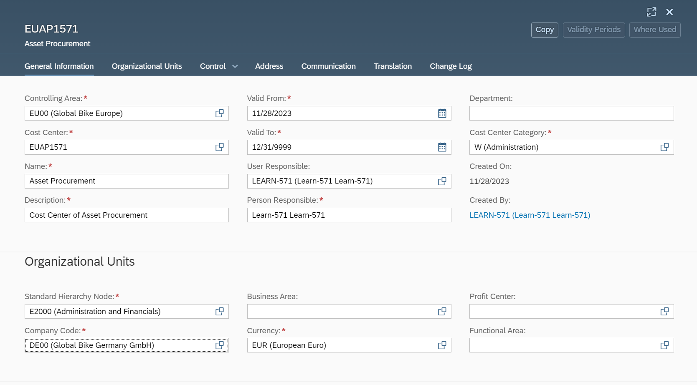
In manage Cost Center in the Controlling Area field entering EU00. As there is no cost centers available for entered Controlling Area, so we creating new cost center.
In the cost center we are writing EUAP1751, as my username 751.
In Organization unit area we’re assign new cost center to the standard hierarchy node E2000.

Step 2: Create Asset
Task: Create an Asset.
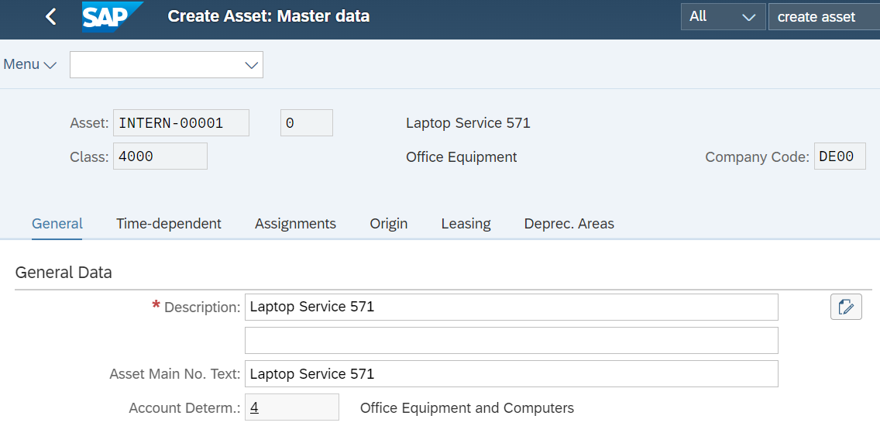
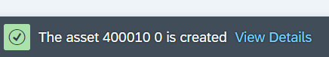
To create new asset we go to Financial Account Area. In the asset calss fiels we enter DE00 as the company code and choose the 4000 Office equipment and computers from the list. And then we master data - General subsection, enter Laptop Service 751 as Description. Switch to the Time-dependent area. Enter EUAP1751 as the cost center and HD00 as the plant. And then save asset.

Step 3: Asset accounting overview
Task: Get an overview of your Asset.

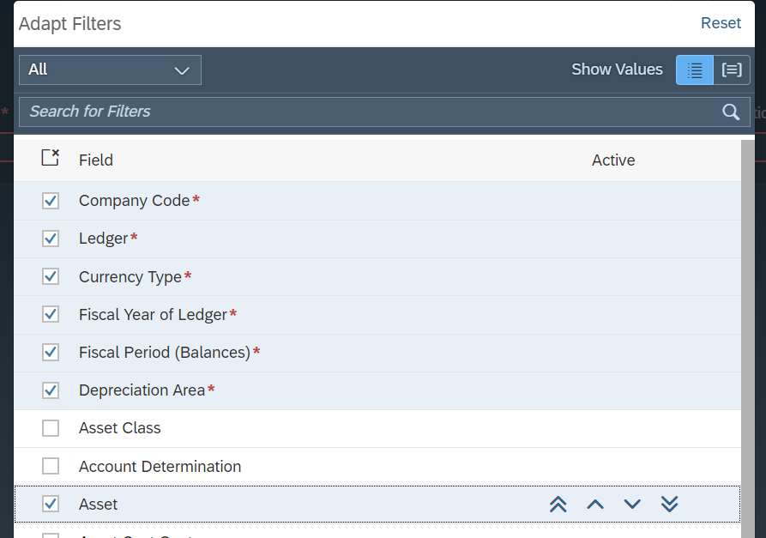
Through Asset Counter Overview Adapt filters from asset class to asset.
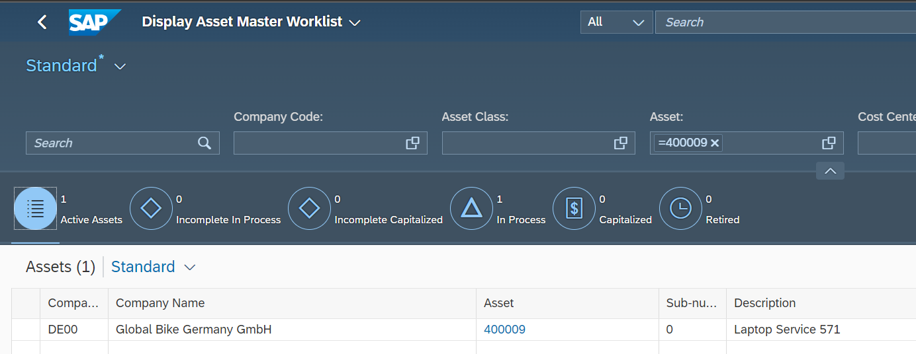
Then in the Company field enter DE00. Select currency type as a 10 and then Save this as a Standard FI-AA and set it as a Default.

Step 4: Create order
Task: Create an order.
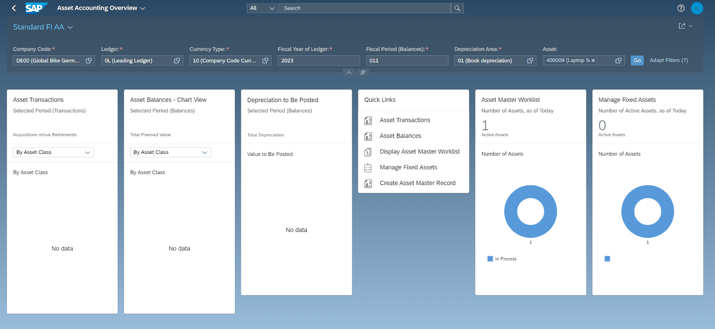

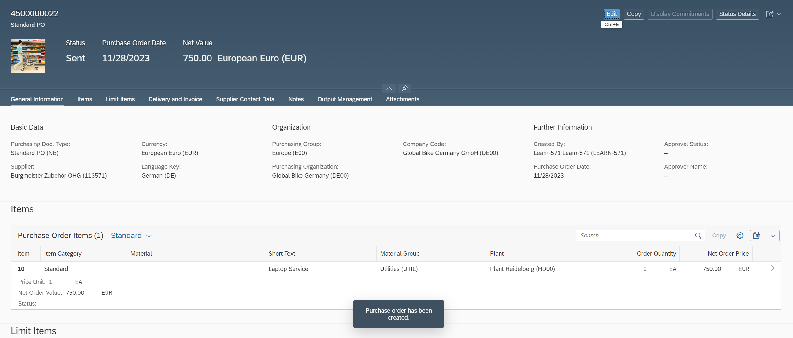
In Manage Purchase Orders screen create order, select Standard PO (NB) as the purchasing Doc. Type. Select 113571 (Burgmeister Zubehör OHG) as the supplier. The currency EUR (European Euro), the purchasing organization Global Bike Germany (DE00) and the company code Global Bike Germany GmbH (DE00) are automatically added with the selection of the supplier and then click Create.
Now we enter Laptop Service and enter HD00 as a plant.
I enterd 750 eur to net order price . In account management area we change Shedule tab and add a delivery date.
Step 5: Post goods receipt
Task: Post the goods receipt for the purchase order.

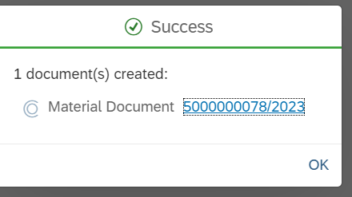
Through Financial Accounting area and Purchasing document field I selected Laptop Service and entered items so I can make my booking.
Step 6: Asset accounting overview
Task: Check your plant after goods receipt.
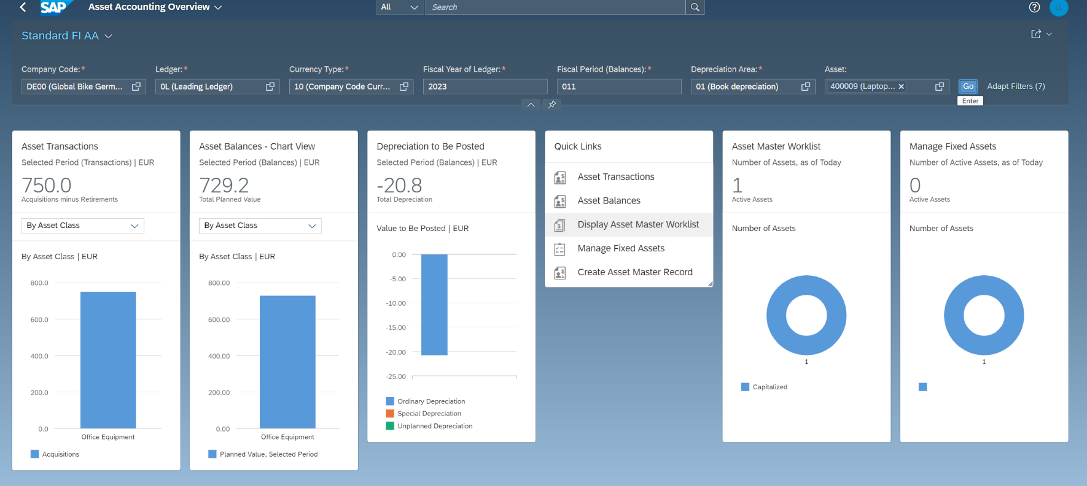
Through pre-saved view that I created earlier, we can look through overview of assets.
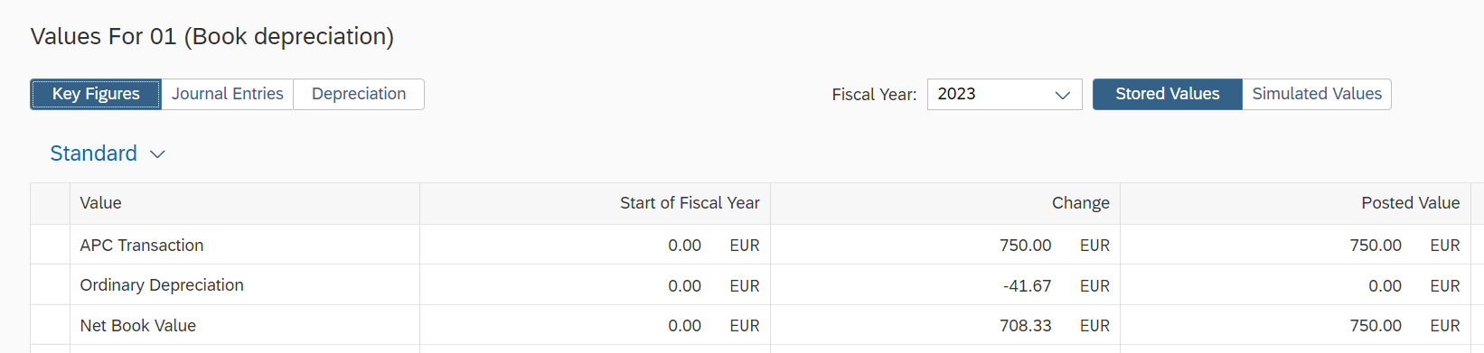
We go into Display Asset Master Worklist. In the Values area, you can see the key figures APC Transaction, ordinary depreciation, and net book value for the entire current year.
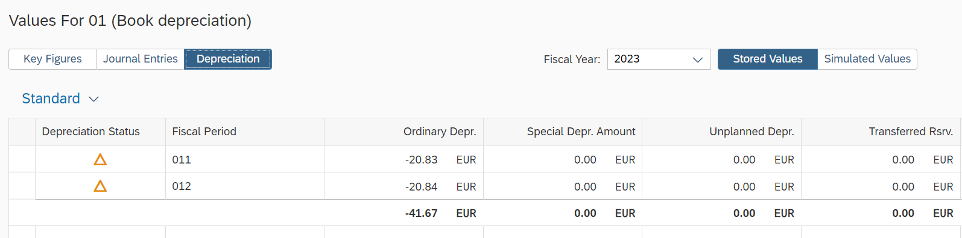
And when we Switch to Depreciation to see an overview of planned depreciation per month.
Step 7: Create supplier invoice
Task: Create a supplier invoice.

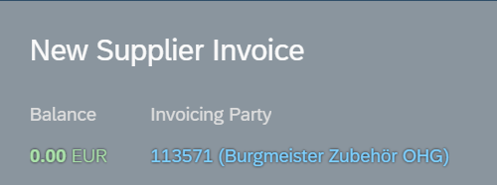
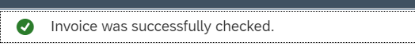
First of all, we checking invoice: adding unplanned delivery cost, and after that clearing the balance by going to the General Information section and gross invoice amount to the balance.
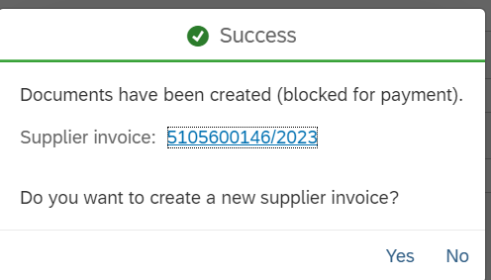
Then we simulate to check the booking in advance. After that we press Post and the unique supplier invoice would be generated.

Step 8: Asset accounting overview
Task: Check your installation after paying the supplier invoice.

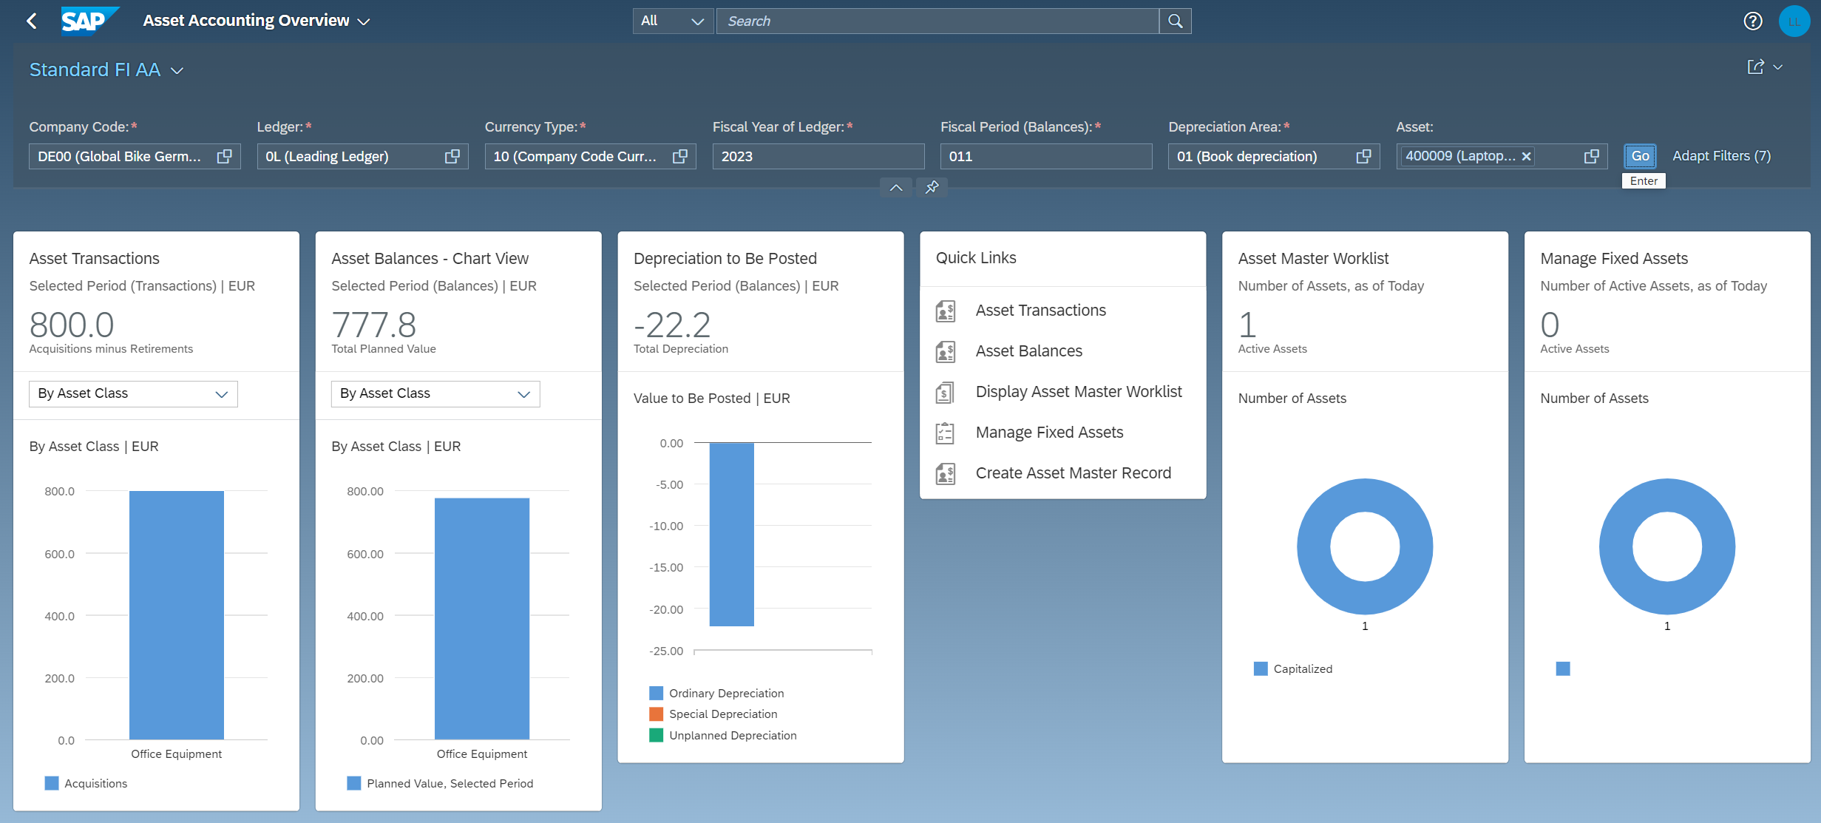
There we can see an overview of your asset.
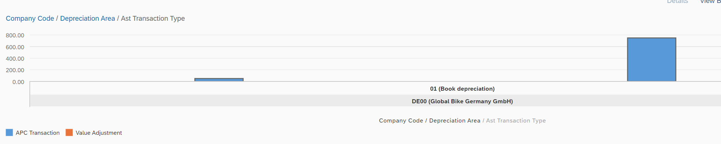
To trach the changes we go the Asset Transactions link.
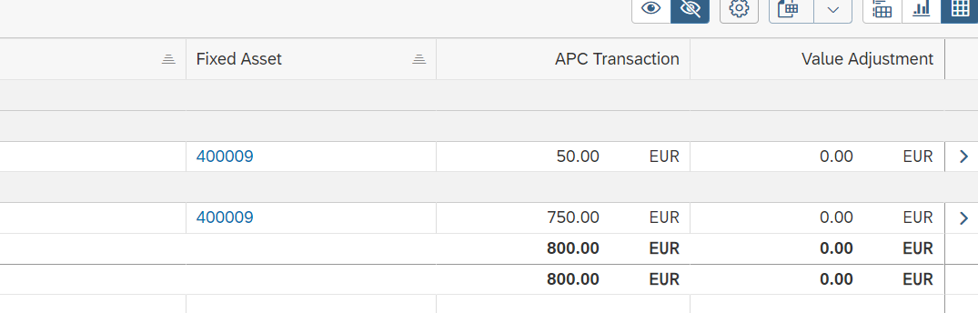
There we can see individual amounts and graphical view.

Step 9: Post Retirement
Task: Post the retirement of your plant

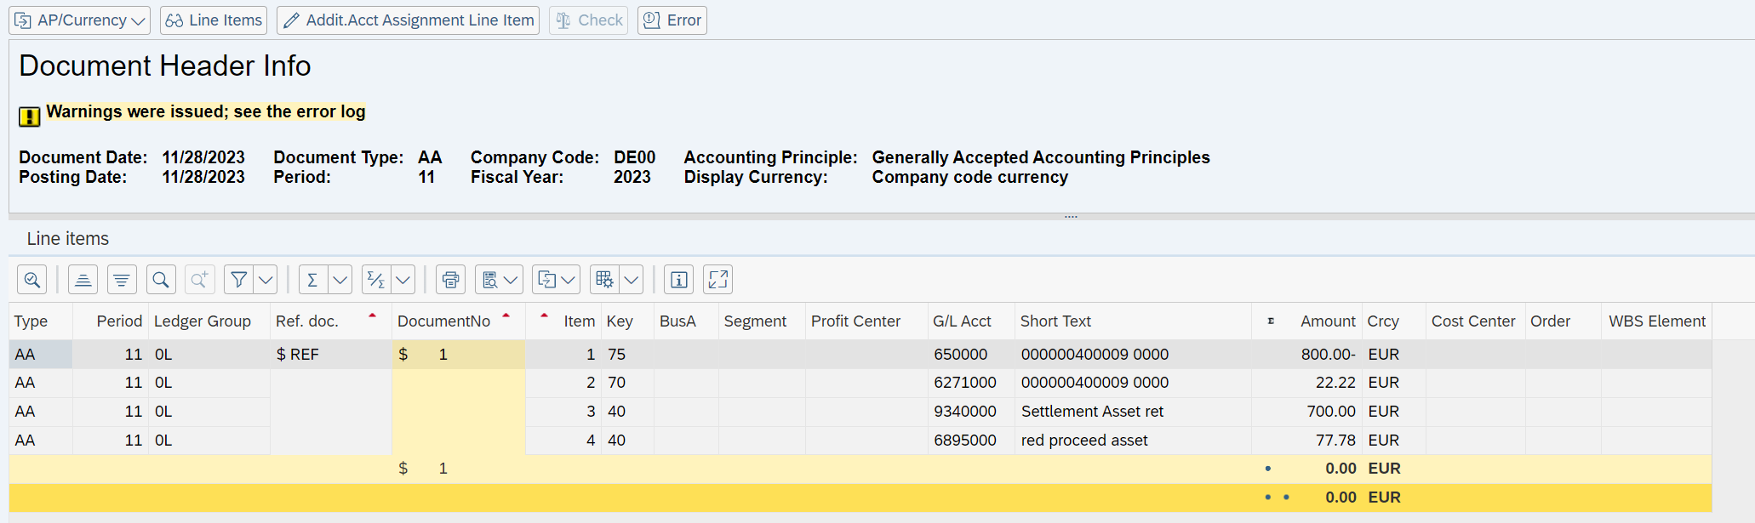
We go through Post Retirement (not-integrated) - Without Customer app. There we select our asset, in the Transaction data area enter GAAP.
After we clicking simulate, we can see all depreciation planned up to the reference date is taken into account.
Step 10: Asset accounting overview
Task: Get an overview after the asset retirement

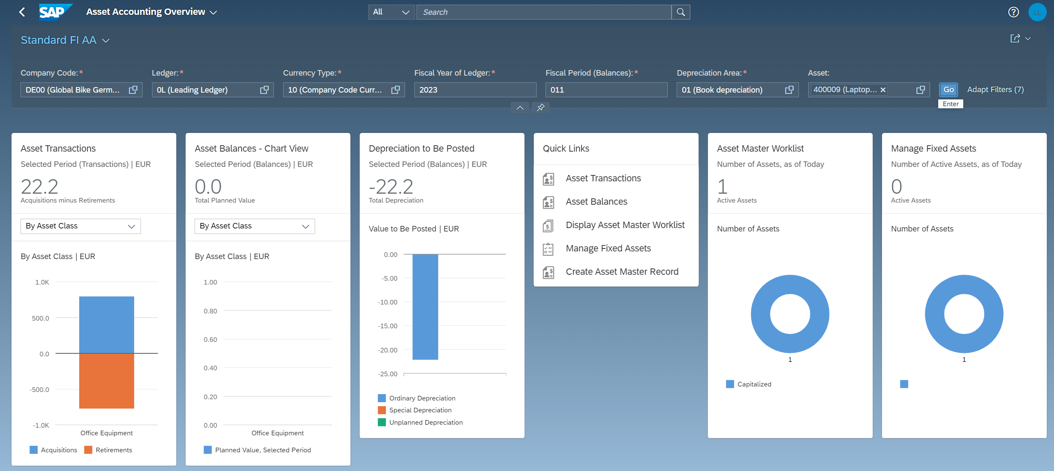
In the asset transaction we can see the retirement of our asset, the current asset inventory list no longer shows an inventory value.

